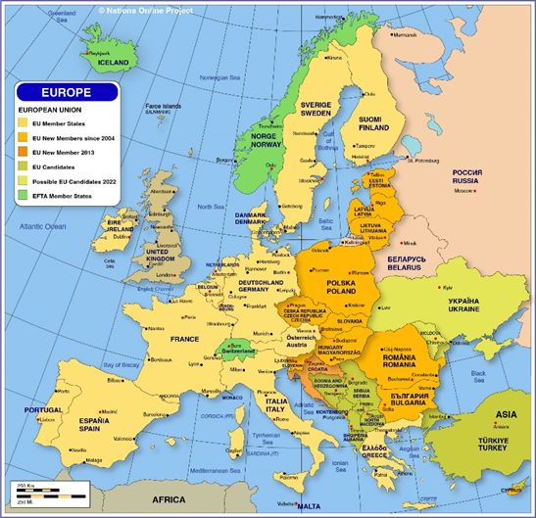
GOVERMENT Ideas for the Ukraine
Dear leaders of countries and UK parties
Form CUTE Countries
Russia must feel increasingly isolated as more countries join NATO and the west.
If a radical leader ever seized control then this could lead to an extension of the current war in Ukraine.
We can alleviate the fears of Russia by asking the central countries to form their own defence organisation.
So the orange countries, including the Ukraine, could form a Central Union Treaty of Europe (CUTE). Poland, Rumania and Bulgaria could be members.
Although this is likely to lean more to the west, it would, officially, be militarily neutral and in the middle. Since these would not be part of NATO it would no longer provide an immediate threat to Russia. Indeed, we would argue that they form a buffer zone between us.
Modern NATO Weaponry
Instead of sending a wide variety of our most modern tanks, helicopters, planes and weapons to the Ukraine, we could send them to Ukraine’s neighbours.
These other countries will be able to undertake the relevant training without any undue urgency.
They would also be able to quickly send their soviet era weaponry to the Ukraine, which the Ukrainians will already know how to handle. Any tank ammunition captured from the Russians could then be sent back.
This has the added advantage of avoiding our technologically advanced weaponry from being captured and copied by the soviets.
Email John Simpson at BBC2 who met President Zelensky.
Form VO or ST or join CUTE
The Scandinavian countries could form their own Scandinavian Treaty or Viking Organisation.
I hope this helps.
Dave Hughes
61 Romsey Road
SO16 4BY

